Name: Mohammad Awais
Class: BSCS-8-A
CMS: 242554

Compiler Construction Lab 6

Common Flex Specification Code

calc.l
%{
#include "calculator.tab.h"
%}

%%

[0-9]+ { yylval = atoi(yytext); return T_Int;}

[-+*/\n] { return yytext[0];}

. { /* ignore everything else */ }

%%

Prefix Calculator

Code:

calculator.y
%{
#include <stdio.h>

void Push(int data);
int Pop();
int Top();

%}

%token T_Int

%%
S : S E '\n' { printf("= %d\n", Top()); }
|
;
E : '+' E E { Push(Pop() + Pop()); }
| '-' E E { int op2 = Pop(); Push(Pop() - op2); }
| '*' E E { Push(Pop() * Pop()); }
| '/' E E { int op2 = Pop(); Push(Pop() / op2); }
| T_Int { Push(yylval); }
;
%%

const int MAXSIZE = 40;
static int stack[40];

void Push(int data){
for (int i = MAXSIZE-1; i>0;i--){
stack[i]=stack[i-1];
}
stack[0] = data;
}

int Pop(){
int data = stack[0];
for (int i = 0; i<MAXSIZE;i++){
stack[i]=stack[i+1];
}
return data;
}

int Top(){
return stack[0];
}

int main() {
return yyparse();
}

Output:
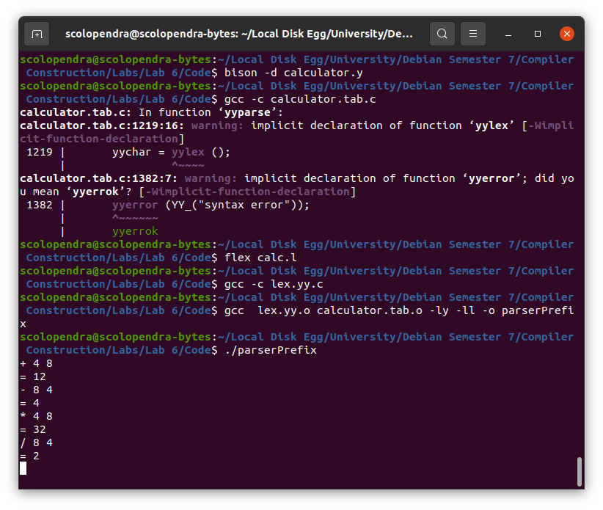

Infix Calculator

Code:

calculator.y
%{
#include <stdio.h>

void Push(int data);
int Pop();
int Top();

%}

%token T_Int

%%
S : S E '\n' { printf("= %d\n", Top()); }
|
;
E : E '+' E { Push(Pop() + Pop()); }
| E '-' E { int op2 = Pop(); Push(Pop() - op2); }
| E '*' E { Push(Pop() * Pop()); }
| E '/' E { int op2 = Pop(); Push(Pop() / op2); }
| T_Int { Push(yylval); }
;
%%

const int MAXSIZE = 40;
static int stack[40];

void Push(int data){
for (int i = MAXSIZE-1; i>0;i--){
stack[i]=stack[i-1];
}
stack[0] = data;
}

int Pop(){
int data = stack[0];
for (int i = 0; i<MAXSIZE;i++){
stack[i]=stack[i+1];
}
return data;
}

int Top(){
return stack[0];
}

int main() {
return yyparse();
}

Output:
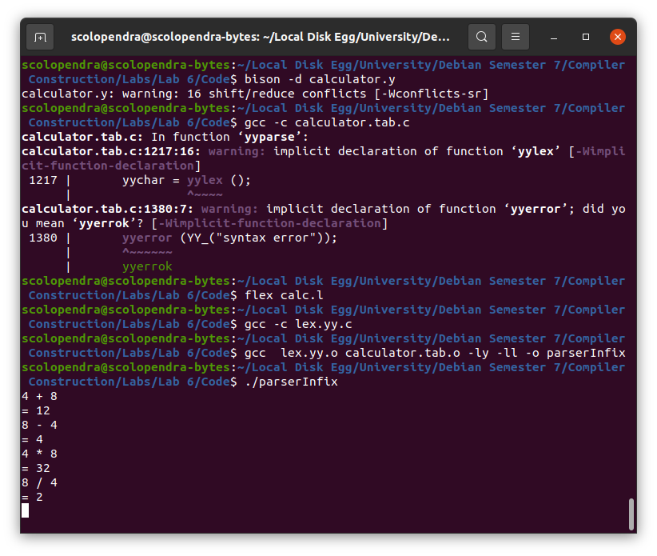

Postfix Calculator

Code:

calculator.y
%{
#include <stdio.h>

void Push(int data);
int Pop();
int Top();

%}

%token T_Int

%%
S : S E '\n' { printf("= %d\n", Top()); }
|
;
E : E E '+' { Push(Pop() + Pop()); }
| E E '-' { int op2 = Pop(); Push(Pop() - op2); }
| E E '*' { Push(Pop() * Pop()); }
| E E '/' { int op2 = Pop(); Push(Pop() / op2); }
| T_Int { Push(yylval); }
;
%%

const int MAXSIZE = 40;
static int stack[40];

void Push(int data){
for (int i = MAXSIZE-1; i>0;i--){
stack[i]=stack[i-1];
}
stack[0] = data;
}

int Pop(){
int data = stack[0];
for (int i = 0; i<MAXSIZE;i++){
stack[i]=stack[i+1];
}
return data;
}

int Top(){
return stack[0];
}

int main() {
return yyparse();
}

Output:
